# Integration of IAM with VPC

**What is IAM?**

AWS IAM is a web service that helps us securely control access to AWS resources. We use IAM to control who is authenticated (signed-in) and authorized(has permission) to use resources.

**What is IAM User?**

An IAM User is an entity that we create under our AWS account to provide authentication for people,application and processes in our AWS account.

**How to create IAM User?**

**Step-1:**

First Need to login to AWS console and then go to service section in that search IAM service

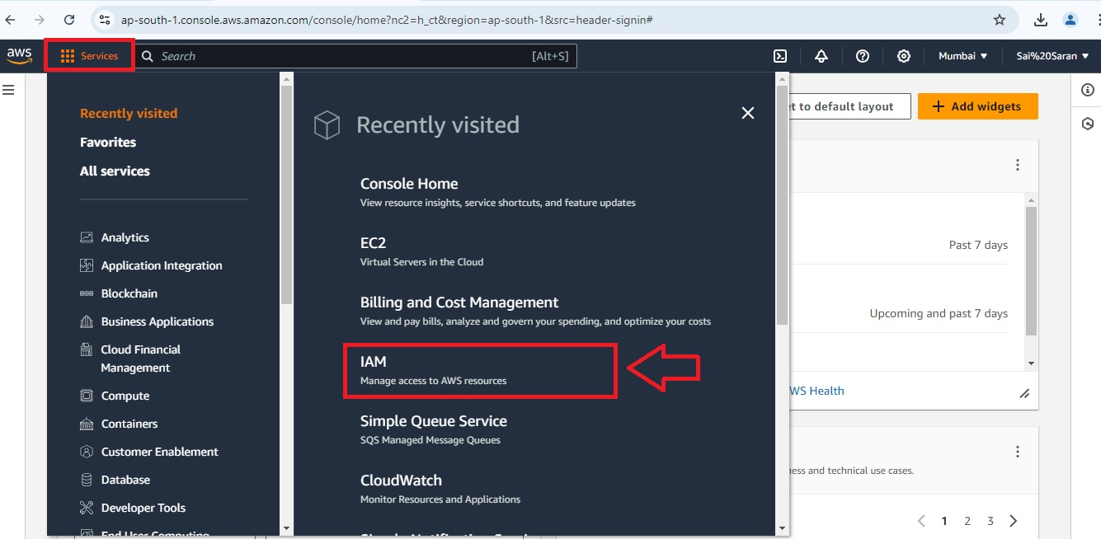

**Step-2:**

In IAM dashboard click on users and then click on the “**Create user”**

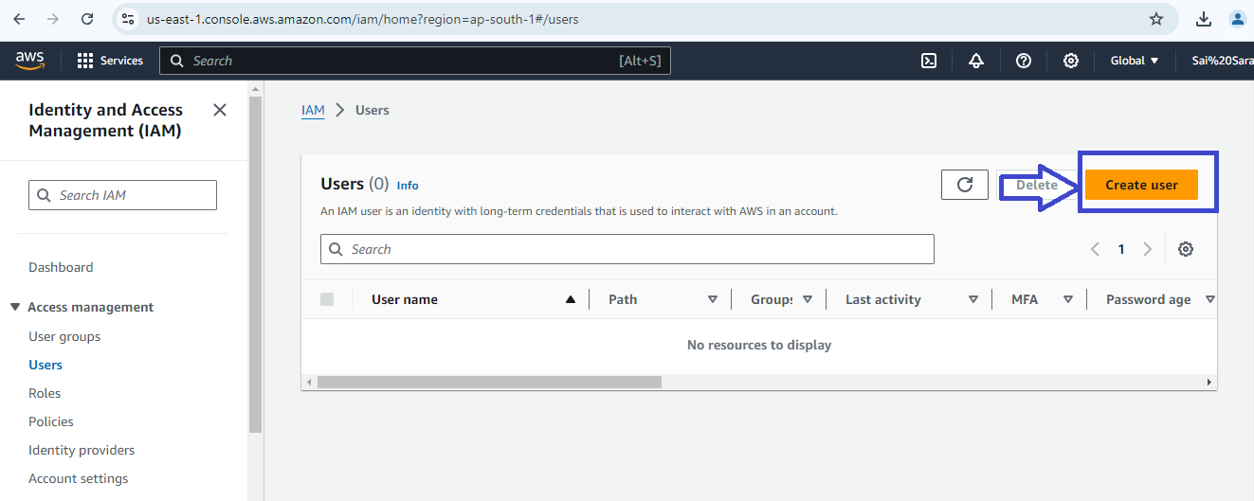

**Step-3:**

Provide the user details

1. Username
2. Tick the check box
3. Select the “**I want to create IAM User**”

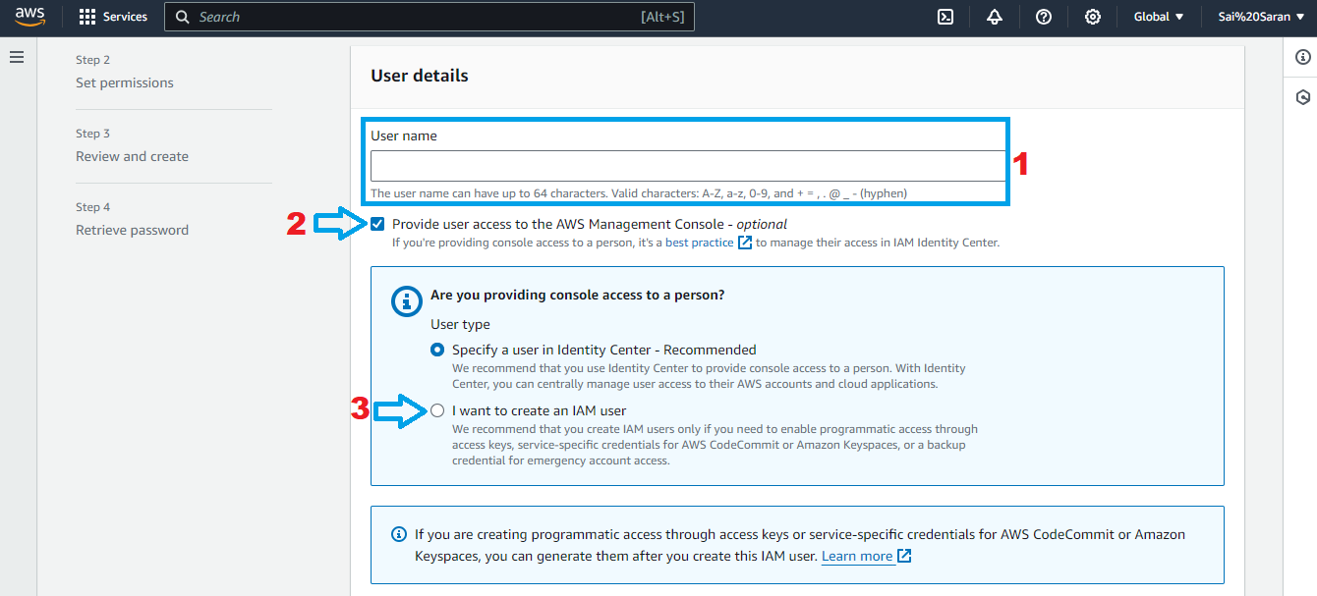

**Step-4:**

Provide the console password in that we can select custom password or Auto-generated password and then click on Next

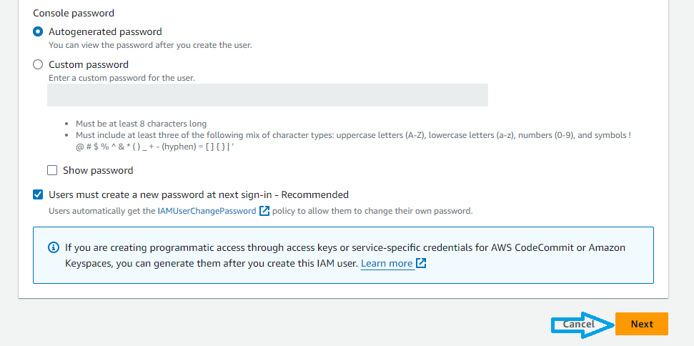

**Step-5:**

After click on the next here set the permission page will be open in that we need to select Attach policies directly

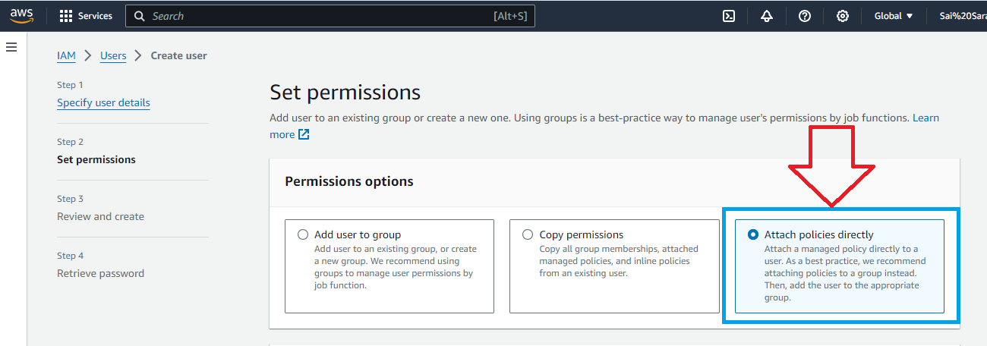

**Step-6:**

In Permission policies we need to select “**AmazonVPCFullAccess”**

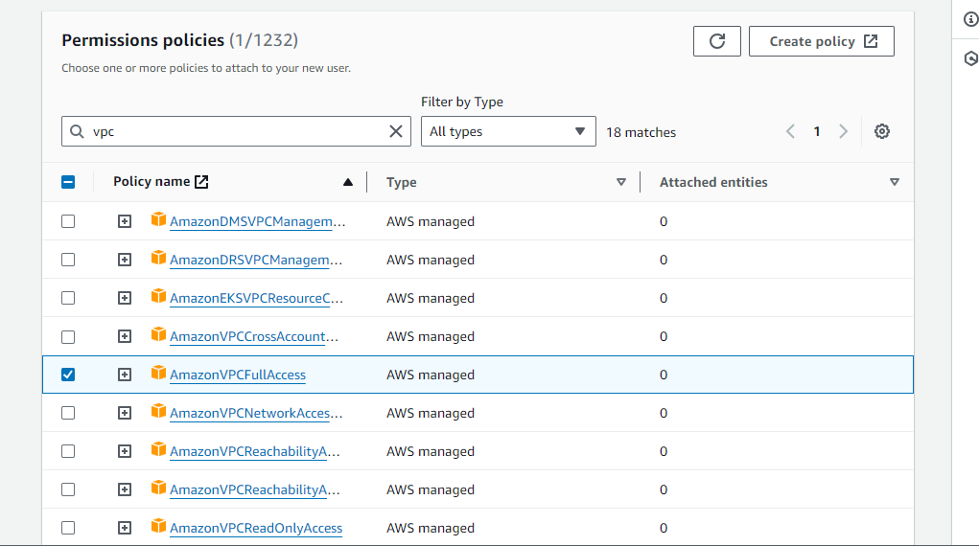

Then click on Next

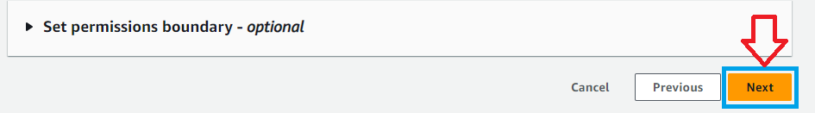

**Step-7:**

After click on the next Review and Create Page will be open in that Review the given information and click on the “**Create User**”

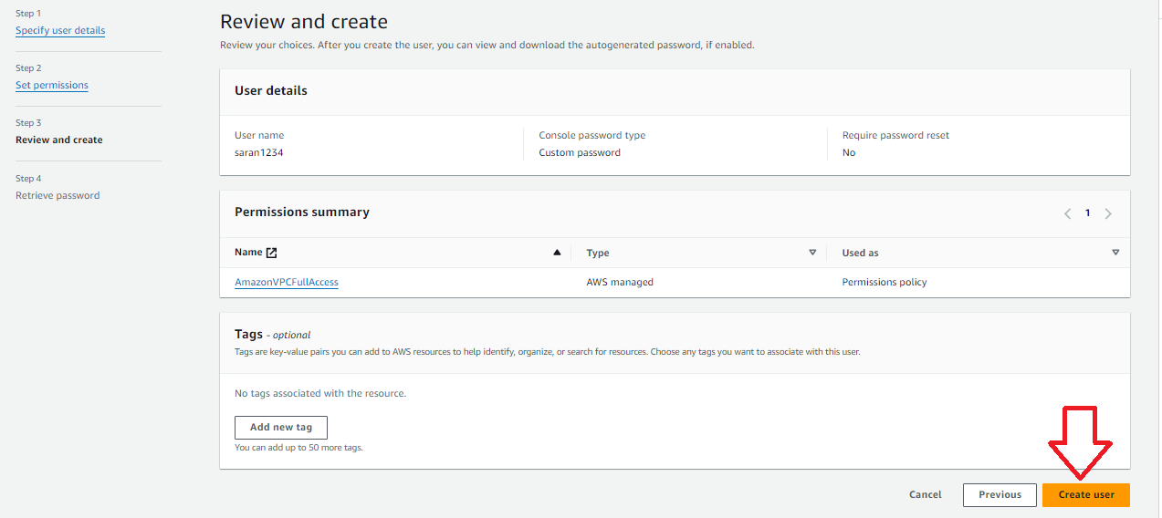

**Step-8:**

After click on Create User the Console sign-in details page

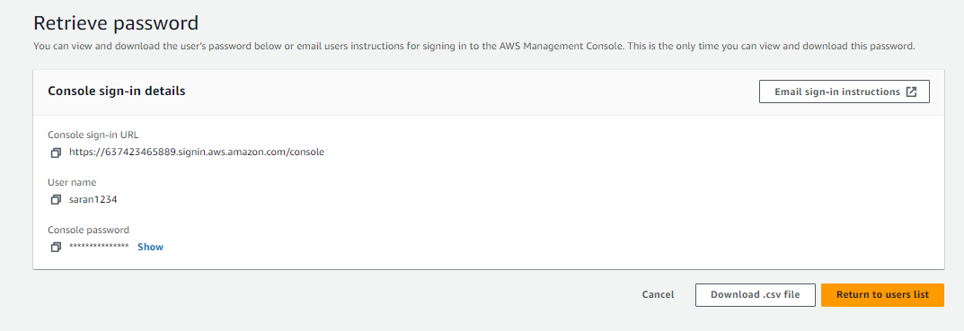

**Step-9:**

After creating user we need to take 12 digit IAM default code

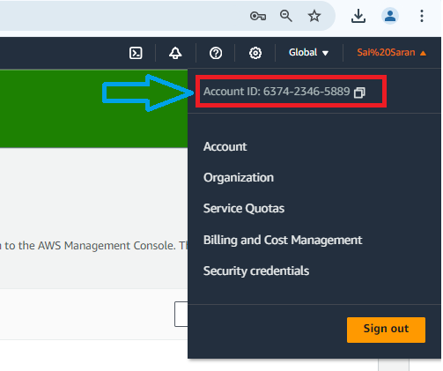

**What is IAM Role?**

* An IAM role,is a set of permissions that grant access to actions and resources in AWS
* These permissions are attached to the role,not to an IAM user or Group.Instead of being
* uniquely associated with one person a role is intended to be assumable by anyone who needs it
* A role does not have standard long-term credentials associated with it
* If a user assumes role temporary security credentials are created dynamically and provided to the user

**Step-10:**

In IAM dashboard click on Role and then click on the “**Create Role”**

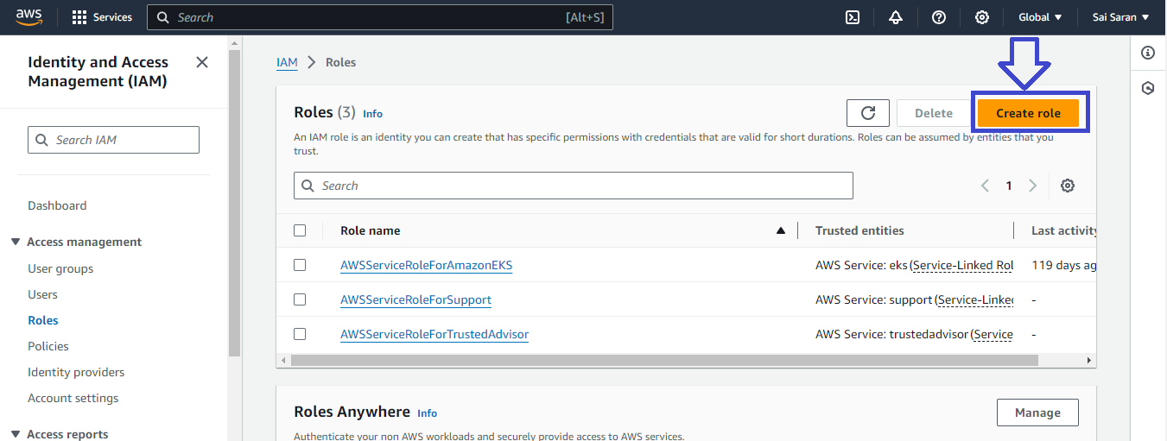

**Step-11:**

After click on the create role select trusted entity page will open in that we need to select **“AWS account”**

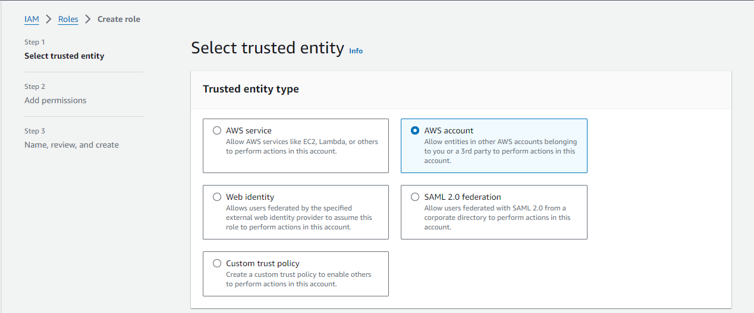

**Step-12:**

In that below we need to enter account Id (12 digit IAM Id), and Tick the **“Required MFA”** box and then Click on Next

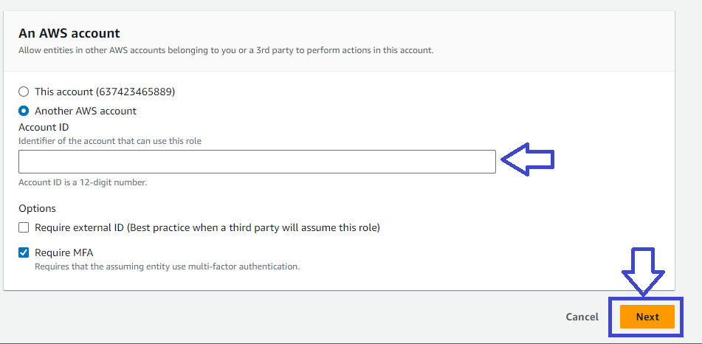

**Step-13:**

After click on Next permissions page will be open In that we need to select “**AmazonVPCFullAccess”**

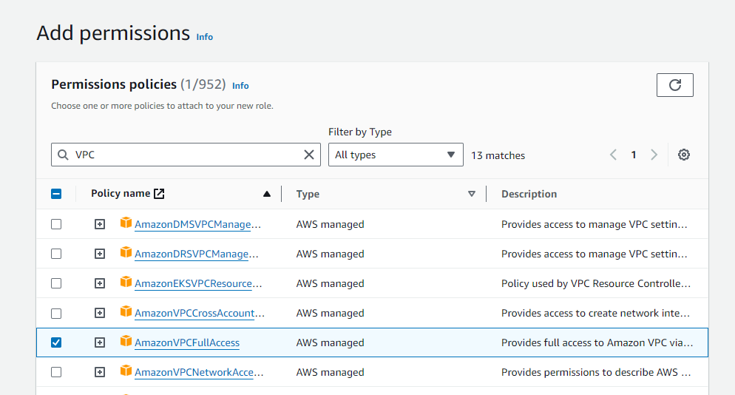

Then click on Next



**Step-14:**

After click on Next Name, Review and Create page will be open in that we need to fill Role details like

1. Role name
2. Description

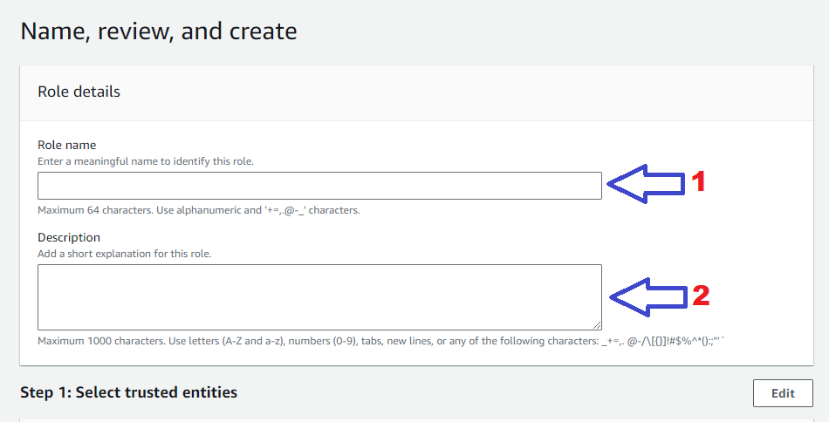

Then Click on **“Create Role”**

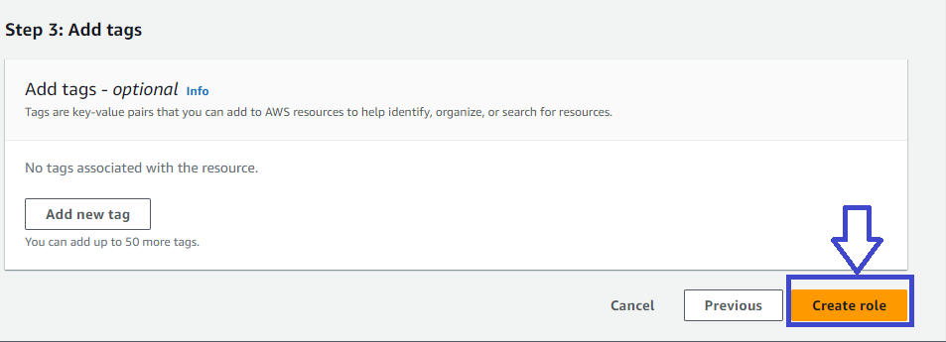

**Step-15:**

After click on Create role we received a **successfully created Role** message in IAM Service

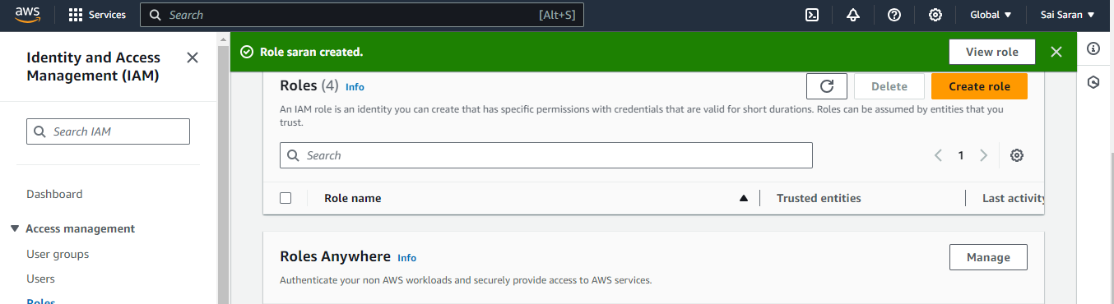

**Step-16:**

After creating a Role Need to sign-in to the IAM User in that we need to enter Account ID(12 digit code),Username and password. And click on sign-in

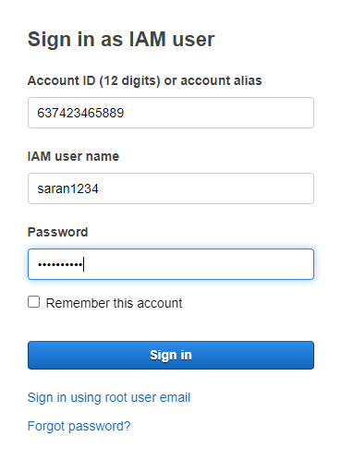

**Step-17:**

After sign-in IAM user console page will be open

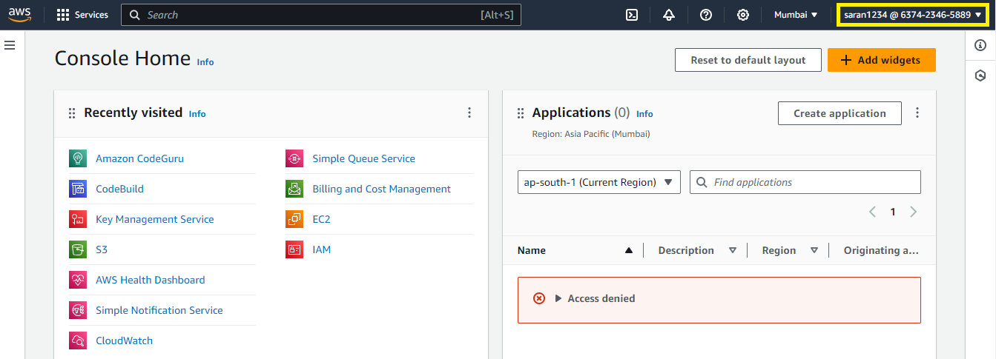

**Note:**In above image we have seen Access denied error.

That error means we have given access to VPC only not for other services so that why the error will occurred.

**What is VPC?**

VPC stands for virtual private cloud. VPC allows you to create a secure,isolated virtual network within the AWS Cloud. In VPC we can define our own IP address range, create subnets, and control traffic between our AWS resources. VPC gives you full control over our network configuration, similar to traditional data center network.

**Step-18:**

In Search bar Need to search for VPC and then click on VPC

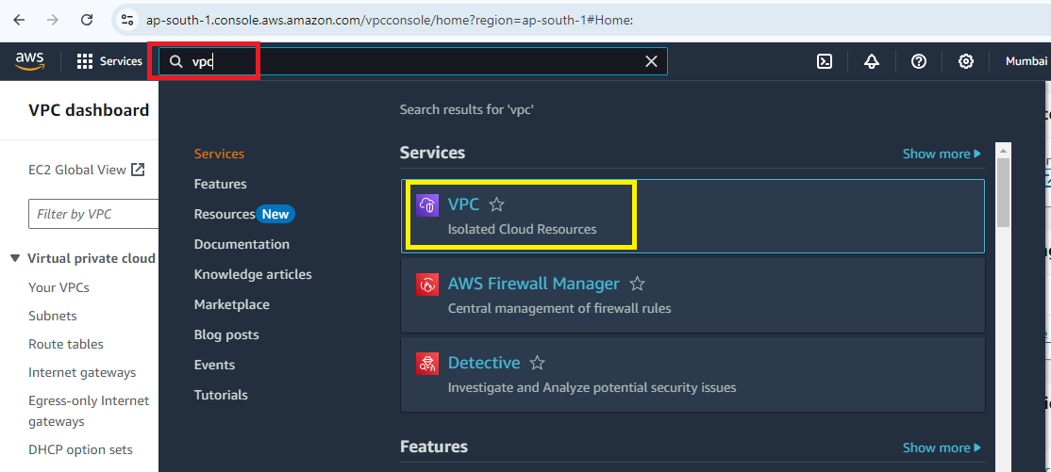

**Step-19:**

In VPC dashboard click on VPCs and then click on the “**Create VPC”**

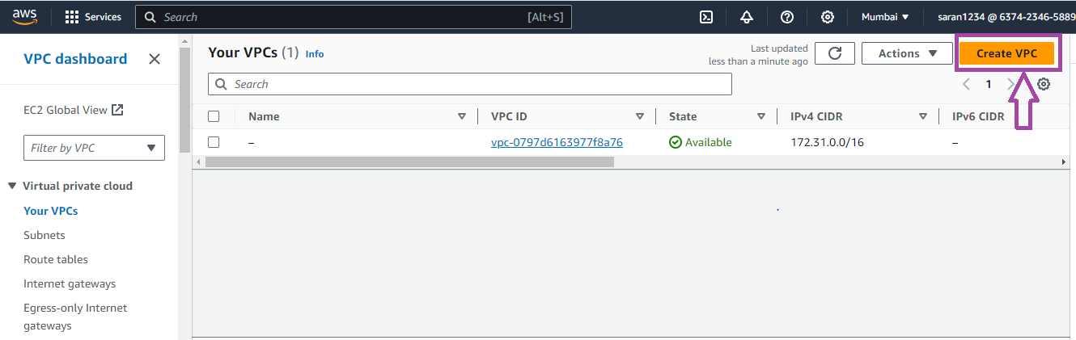

**Step-20:**

After click on create VPC next page will open in that we need to enter some information like

1. Here select VPC Only
2. Enter Name tag
3. Here we need to enter IP address (ex: 10.0.0.0/16)

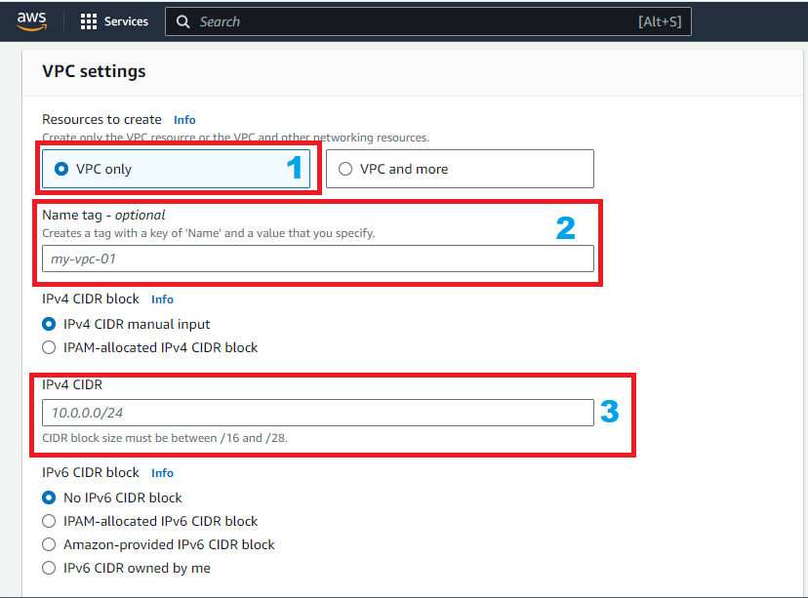

Then click on “**Create VPC”**

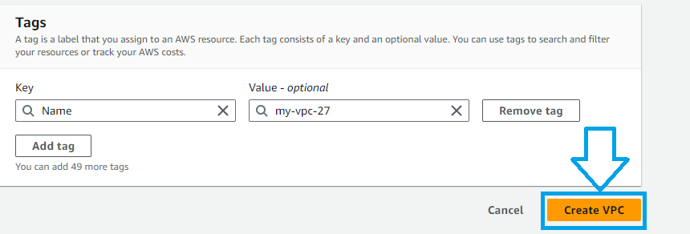

**Step-21:**

After click on create VPC we received **successfully created VPC** message in IAM User

